Week 5 - Wednesday Questions

1. List all customers who live in Texas (use JOINs)
   1. 10 Jennifer Davis Texas
   2. 122 Kim Cruz Texas
   3. 310 Richard Mccrary Texas
   4. 405 Bryan Hardison Texas
   5. 567 Ian Still Texas
2. Get all payments above $6.99 with the Customer's Full Name
   1. 343 8.99 Douglas Graf
   2. 347 8.99 Ryan Salisbury
   3. 347 8.99 Ryan Salisbury
   4. 347 7.99 Ryan Salisbury
   5. …
   6. …
   7. …
   8. 341 12.99 Peter Menard
   9. 341 14.99 Peter Menard
   10. 341 14.99 Peter Menard
   11. 341 21.99 Peter Menard
3. Show all customers names who have made payments over $175(use subqueries)
   1. 137 Rhonda Kennedy
   2. 144 Clara Shaw
   3. 148 Eleanor Hunt
   4. 178 Marion Snyder
   5. 341 Peter Menard
   6. 459 Tommy Collazo
   7. 526 Karl Seal
4. List all customers that live in Nepal (use the city table)
   1. {none}
5. Which staff member had the most transactions?
   1. ***2 Jon Stephens 7304***
   2. 1 Mike Hillyer 7292
6. How many movies of each rating are there?
   1. 178 G
   2. 194 PG
   3. 195 R
   4. 210 NC-17
   5. 223 PG-13
   6. 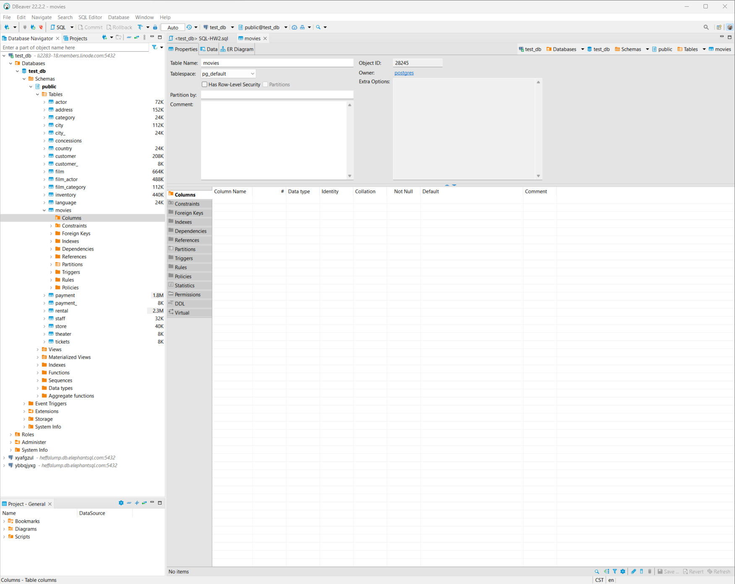
7. Show all customers who have made a single payment above $6.99 (Use Subqueries)
   1. 1 Mary Smith
   2. 2 Patricia Johnson
   3. 3 Linda Williams
   4. 4 Barbara Jones
   5. …
   6. …
   7. …
   8. 594 Eduardo Hiatt
   9. 595 Terrence Gunderson
   10. 598 Wade Delvalle
   11. 599 Austin Cintron
8. How many free rentals did our stores give away?
   1. 14 1 0.00
   2. 10 2 0.00